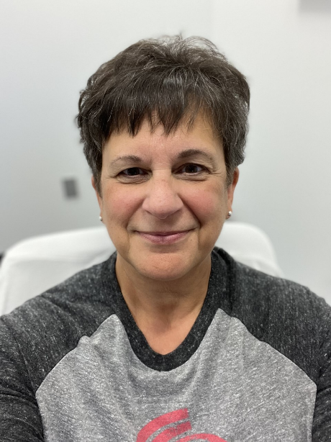
When I was in 6th grade, my mom became very ill. My mom was my best friend and I was the baby of the family – this was devastating for me. From this time until I graduated high school, my mom would be hospitalized over 7 times, often for several weeks at a time and requiring visiting nurse visits once she was home. She ultimately passed away when I was in my early 20s leaving a huge hole in my life. The year following her death, I lost my sister in a violent accident, and a few years after that while my dad was recuperating in the hospital, my brother very unexpectedly passed away. Having to tell my dad this news while he was ill was gut-wrenching. Sadly, three years later I buried my dad. In between all of this, I was diagnosed with cancer and underwent many months of treatments. For a long time I was just in survival mode trying to raise a family and stay positive….hopefully I have been successful – you never know what stories people have behind those eyes.
